

**Micro:Bit (Rock, Paper, Scissors) Game**

This guide of how to implement Rock – Paper – Scissors Game with Micro:Bit.

**The Game Idea**

2 players will compite with each other by Shaking the Micro:Bit for random Choice Between (Rock – Paper - Scissors)

* Rock defeats Scissors
* Scissors defeats paper
* Paper defeats Rock

The player will count for his wins until he win in 3 rounds, Then he will win the game

To implement this game, we will use MakeCode Editor by Microsoft.

**Step 1:** Open this link <https://makecode.microbit.org/> to open MakeCode Editor.

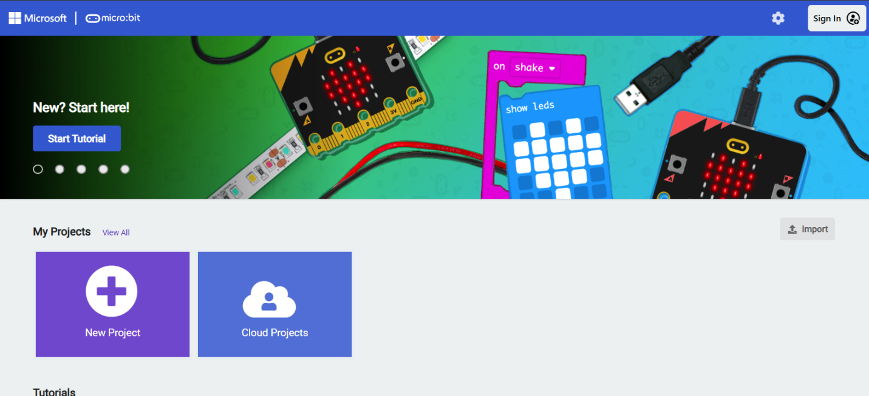

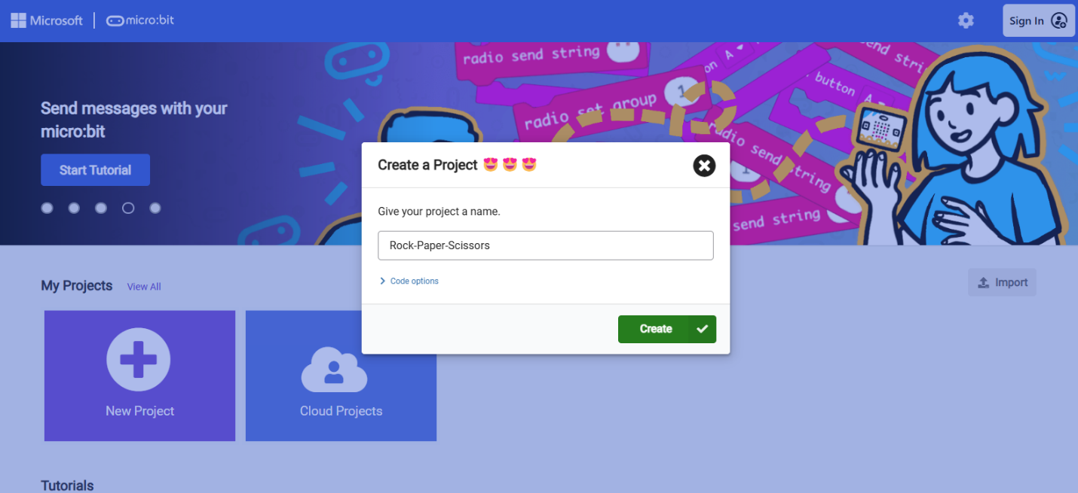**Step 2:** Press on New Project and name the project (Rock-Paper-Scissors) then press **Create.**

Then the programing environment will appear:

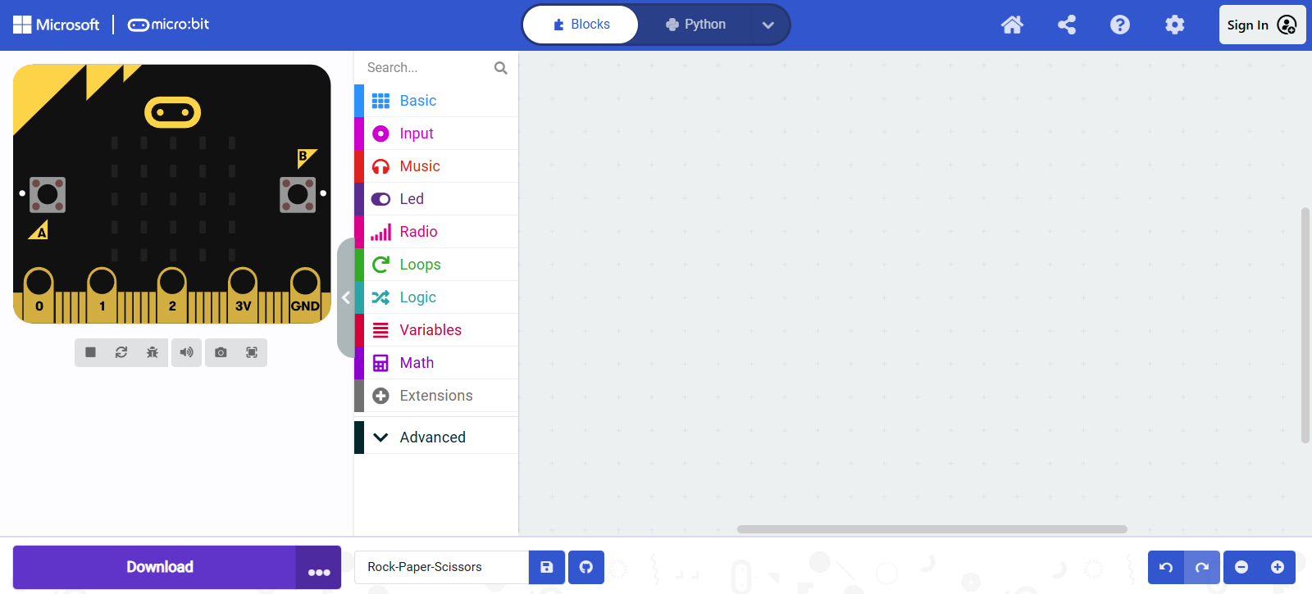

****

**Step 3:** from drag to the environment:

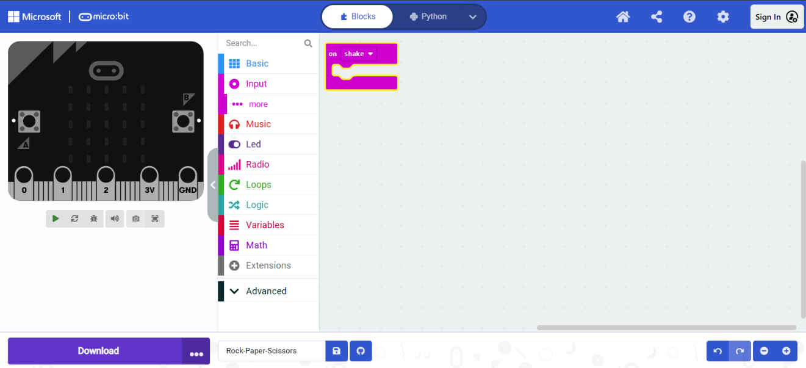

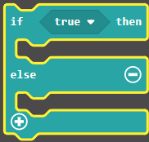

**Step 4:** from drag to the environment and inside the previous block like so:

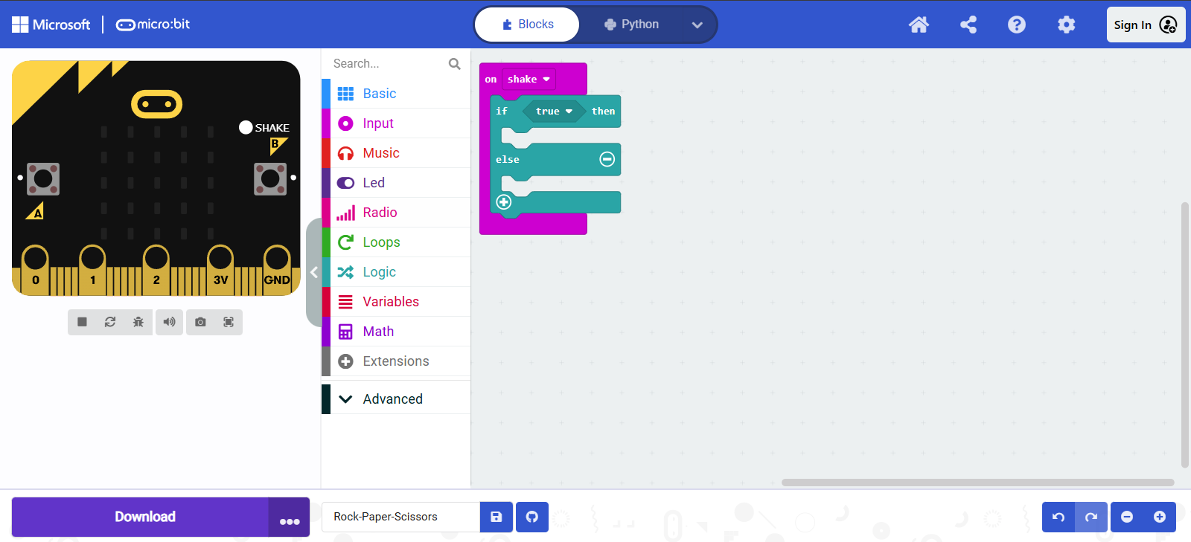

Then press the plus sign to change the block structure to be like this



**Step 4**: From press and name it (RandNum) press OK :

these 3 new blocks will appear

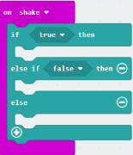



**Step 5**: Chose and drag it above the green block



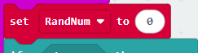**Step 6:** From Scroll down until find change 0 to be 1 and 10 to be 3 then drag this block here

**Step 7:** Fromchose and fromchose

drag it here to be like this then **COPY** it (Chose the

Block and press CTRL + C) it and **PASTE** it (press CTRL + V), Now you have 2 of this block change the zero in the first shape to be 1 like this Change the 0 in the

second one to be 2 to be like this this what you should see:

Place the Blocks here:

To be like this:

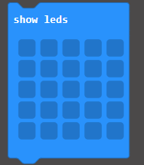

**Step 8**: From drag 3 blocks of here:

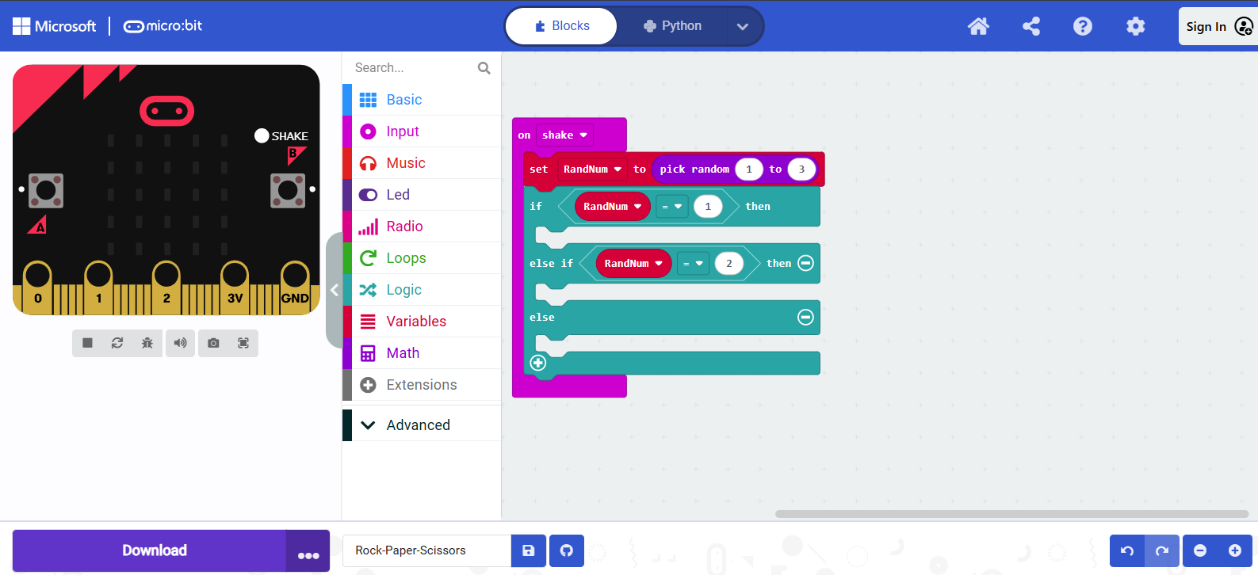

To be like this:

Now you are almost done, you just need to draw the (Rock-paper-Scissors) shapes

On the last block Rock: paper: Scissors:

To draw you can just click on the squares then it will turn white.

Now this is the end of the program:

Now you can test the program click **SHAKE** button in the Micro:Bit of MakeCode Editor:

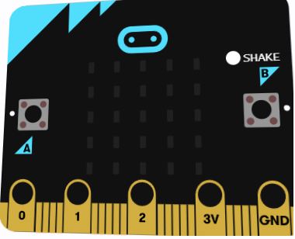

And to download the program in the real Micro:Bit plug the USB cable to the computer and the Micro:Bit then press DOWNLOAD button

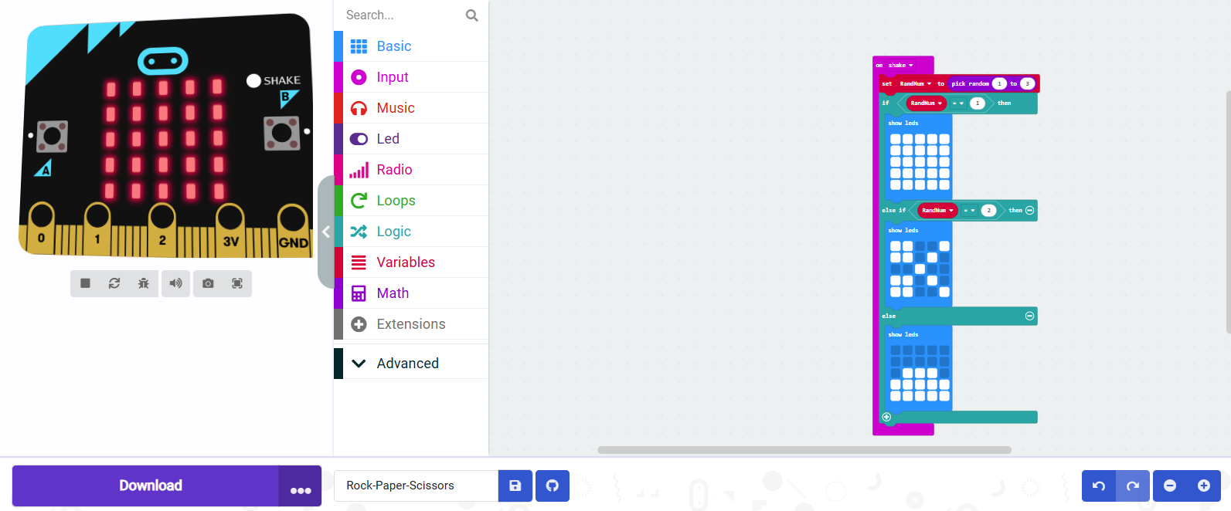

**Now you can enjoy playing the game that you have created.**